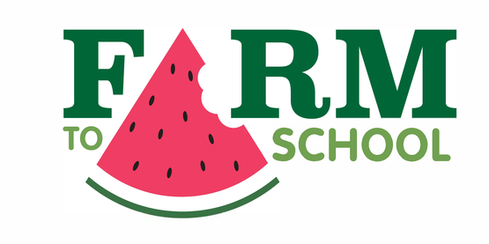
Monday | Tuesday | Wednesday | Thursday | Friday
2  No School  Winter Recess | 3  Chocolate Chip Muffin w/Assorted Yogurt  - - - - - - - - - - - - - -  Juice Cup 4oz  Fruit 1/2c  Milk -8oz | 4  Pillsbury Cinni Minis  - - - - - - - - - - - - -  Juice Cup 4oz  NYS Apples – 1 Piece  Milk-8oz | 5  Blueberry Muffin w/Assorted Yogurt  - - - - - - - - - - - - - -  Juice Cup 4oz  Fruit 1/2c  Milk -8oz | 6  Pills Cinni Minis  - - - - - - - - - - - - -  Juice Cup 4oz  NYS Apples – 1 Piece  Milk-8oz
9  Assorted Muffin w/Assorted Yogurt  - - - - - - - - - - - - - -  Juice Cup 4oz  Fruit 1/2c  Milk -8oz | 10  Croissant Breakfast Sandwich w/Sausage  - - - - - - - - - - - - -  Juice Cup 4oz  Fresh Fruit – 1 Piece  Milk-8oz | 11  English Muffin Sandwich w/Sausage  - - - - - - - - - - - - - -  Juice Cup 4oz  Fruit 1/2c  Milk -8oz | 12  Breakfast Pizza w/Sausage  - - - - - - - - - - - - -  Juice Cup 4oz  Fresh Fruit – 1 Piece  Milk-8oz | 13  Bagel Breakfast Sandwich  w/Sausage  - - - - - - - - - - - - - -  Juice Cup 4oz  Fruit 1/2c  Milk -8oz
16  No School  Martin Luther King, Jr. Day | 17  Croissant Breakfast  Sandwich w/Sausage  - - - - - - - - - - - - - - -  Juice Cup 4oz  Fruit 1/2c  Milk -8oz | 18  English Muffin Sandwich  w/Sausage  - - - - - - - - - - - - - - - -  Juice Cup 4oz  NYS Apples – 1 Piece  Milk-8oz | 19  Breakfast Pizza w/Sausage  - - - - - - - - - - - - - -  Juice Cup 4oz  Fruit 1/2c  Milk -8oz | 20  Bagel Breakfast Sandwich w/Sausage  - - - - - - - - - - - - - - - -  Juice Cup 4oz  Fruit 1/2c  Milk-8oz
23  Breakfast Pizza w/Sausage  - - - - - - - - - - - - - -  Juice Cup 4oz  Fruit 1/2c  Milk -8oz | 24  Croissant Breakfast  Sandwich w/Sausage  - - - - - - - - - - - - - - - -  Juice Cup 4oz  Fruit 1/2c  Milk-8oz | 25  English Muffin Sandwich  w/Sausage  - - - - - - - - - - - - - -  Juice Cup 4oz  Fresh Fruit – 1 Piece  Milk -8oz | 26  Breakfast Pizza w/Sausage  - - - - - - - - - - - - - - - -  Juice Cup 4oz  Fruit 1/2c  Milk-8oz | 27  Bagel Breakfast Sandwich  w/Sausage  - - - - - - - - - - - - - - - - -  Juice Cup 4oz  Fruit 1/2c  Milk -8oz
30  Croissant Breakfast  Sandwich w/Sausage  - - - - - - - - - - - - - - - -  Juice Cup 4oz  Fruit 1/2c  Milk-8oz | 31  Croissant Breakfast Sandwich w/Sausage  - - - - - - - - - - - - - -  Juice Cup 4oz  Fruit 1/2c  Milk -8oz
January 2023 Breakfast Menu 5th-12th $1.65
Tapestry Breakfast Menu

Menu is subject to change.

Month
Year
NYS LOCAL FOODS
*Upstate Farms Dairy
milk and yogurt

*LynOaken Farms Apples

*Local Farms Fruit

This institution is an equal opportunity provider and employer.

Breakfast Menu

Served Daily

Assorted Cereal w/Grain

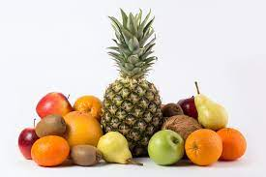

Offered daily
with all School Breakfast:
Fresh or Prepared Fruit
(Must take ½ cup of Fruit – may take up to 1 cup)

NY State Non or Low Fat White Milk 8oz

