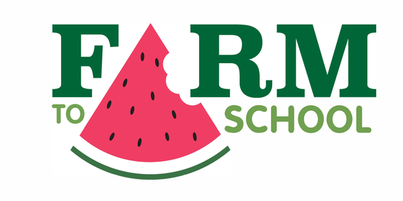
Monday | Tuesday | Wednesday | Thursday | Friday
2  No School  Winter Recess | 3  Buffalo Chicken Macaroni and Cheese or Macaroni and Cheese  - - - - - - - - - - - - - -  Baked Beans 1/2c  Carrots 1/2c  Fresh Fruit – 1 Piece  Milk -8oz | 4  Cheese and Pepperoni Pizza  - - - - - - - - - - - - - -  Green Beans 1/2c  Corn 3/4c  NYS Apple-1 Piece  Milk-8oz | 5  Chicken Alfredo over Brown Rice  - - - - - - - - - - - - - - -  Broccoli 1/2c  Seasoned Tomatoes 3/4c  NYS Apple-1 Piece  Milk-8oz | 6  Grilled Cheese Sandwich w/Tomato Soup  - - - - - - - - - - - - - -  Peas 1/2c  Fruit 1/2c  Milk-8oz
9  French Toast Sticks w/Syrup and String Cheese  - - - - - - - - - - - - - -  Broccoli 1/2c  Carrots 1/2c  Fresh Fruit-1 Piece  Milk-8oz | 10  Chicken Fajita Taco w/lettuce, Cheese, and Salsa  - - - - - - - - - - - - - -  Peas 1/2c  Corn 1/2c  Fruit 1/2c  Milk-8oz | 11  Chicken Tenders w/Seasoned Rice  - - - - - - - - - - - - - -  Green Beans 1/2c  Cauliflower 1/2c  NYS Apple-1 Piece  Milk-8oz | 12  Buffalo Chicken Wing  Pizza  - - - - - - - - - - - - - - -  Sweet Potatoes 3/4c  Mixed Vegetables 1/2c  NYS Apple-1 Piece  Milk-8oz | 13  Hamburger or Cheeseburger on a Bun  - - - - - - - - - - - - - - -  Vegetarian Beans 1/2c  1c Romaine=1/2c  Fruit 1/2c  Milk-8oz
16  No School  Martin Luther King, Jr. Day  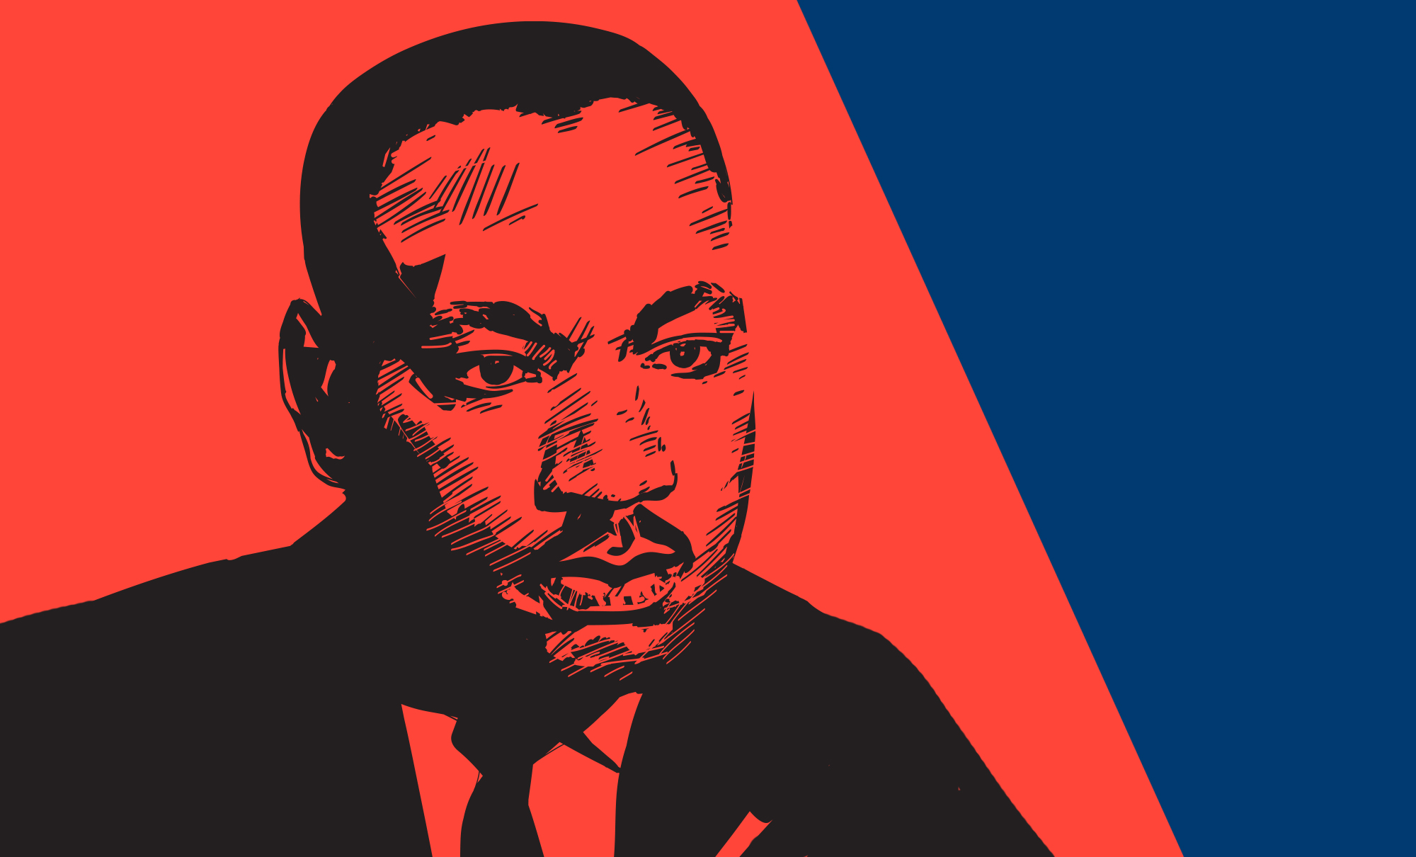 | 17  Taco w/Meat, Cheese,  Lettuce and Salsa  - - - - - - - - - - - - - -  Baked Beans 1/2c  Green Beans 1/2c  Fresh Fruit – 1 Piece  Milk -8oz | 18  Chicken Nuggets  w/Seasoned Rotini  - - - - - - - - - - - - - -  Corn 1/2c  NYS Winter Squash 1/2c  Fresh Fruit – 1 Piece  Milk -8oz | 19  Spaghetti w/Meatballs and a Warm Dinner Roll  - - - - - - - - - - - - - - -  Mixed Vegetables 1/2c  Broccoli 1/2c  Fruit 1/2c  Milk-8oz | 20  Grilled Cheese Sandwich  w/Tomato Soup  - - - - - - - - - - - - - -  Green Peas 1/2c  Carrots 3/4c  Fruit 1/2c  Milk-8oz
23  Sweet and Sour  Chicken Over Rice  - - - - - - - - - - - - - -  Diced Carrots 3/4c  Oriental Vegetables 1/2c  Fruit 1/2c  Milk-8oz | 24  Nacho Grande w/Tostitos  Chips, Lettuce, Cheese and  Salsa  - - - - - - - - - - - - - -  Green Beans 1/2c  Cauliflower 1/2c  NYS Apple - 1 Piece  Milk-8oz | 25  Hamburger or  Cheeseburger on a Bun  - - - - - - - - - - - - - - -  Vegetarian Beans 1/2c  NYS Winter Squash 1/2c  Fruit 1/2c  Milk-8oz | 26  Spaghetti and Meatballs  w/a Dinner Roll  - - - - - - - - - - - - - - -  Broccoli 1/2c  Corn 1/2c  Fruit 1/2c  Milk-8oz | 27  Chicken Tenders w/Seasoned Rice  - - - - - - - - - - - - - - - -  1 c Romaine 1/2c  Sweet Potatoes 1/2c  Fruit 1/2c  Milk-8oz
30  Chicken Tender Sub  w/Lettuce & Tomato  - - - - - - - - - - - - - -  Diced Carrots 3/4c  Green Beans 1/2c  Fruit 1/2c  Milk-8oz | 31  Taco w/Meat, Cheese,  Lettuce and Salsa  - - - - - - - - - - - - - -  Baked Beans 1/2c  Corn 1/2c  Fresh Fruit – 1 Piece  Milk -8oz | 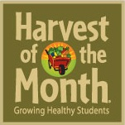  NYS Winter Squash  NYS Apples | 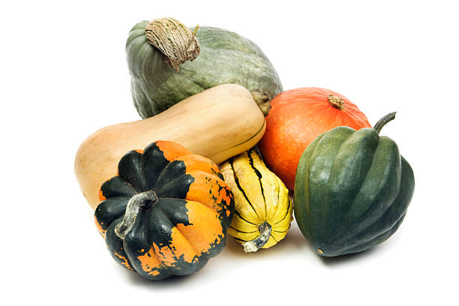 | 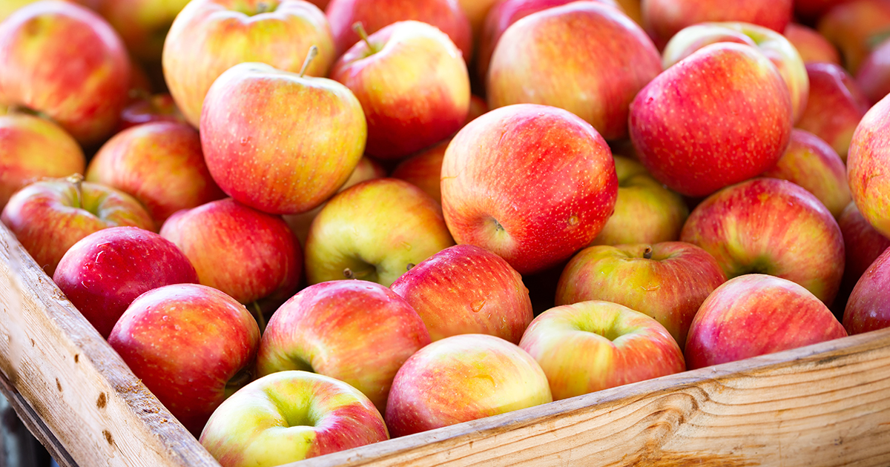
January 2023 Lunch Menu 5-12th Grade $2.65

Tapestry Charter School Lunch Menu

Menu is subject to change.

Month
Year
NYS LOCAL FOODS
*Upstate Farms Dairy
-milk, yogurt, sour cream
*LynOaken Farms Apples
*Local Farm Vegetables and Fruit
used in Meal Program
highlighted in green
This institution is an equal opportunity provider and employer.

Offered daily
with all School Lunches:
Fresh or Prepared Fruit
(Must take ½ cup of Fruit or Vegetable – may take up to 1 cup)

NY State Non or Low Fat White or
Non Fat Chocolate Milk 8oz

In addition to the Entrée of the Day, we also serve the following Items Daily:

Peanut Butter & Jelly Sandwich (2M2G)

